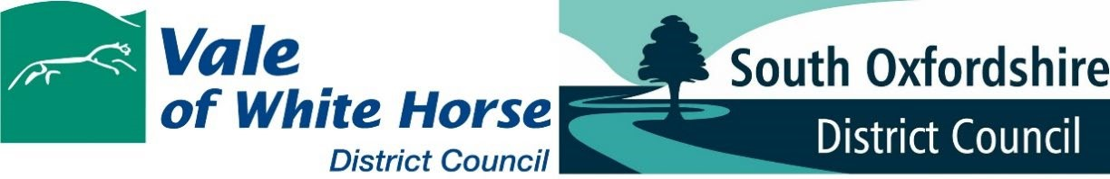
Certificate of Lawfulness of Proposed Use or Development Application Validation Checklist
Complete this checklist and submit it with your certificate of lawfulness of proposed use or development to confirm that the works or development being proposed would be lawful and not require express planning permission.
You will need to submit this completed checklist with your application. It will not be accepted without it.
Guidance and information on the drawing and documents listed below can be found in our Validation Checklist Guidance Note.

National requirements
Requirement | Included – Y/N | If No, short statement why detail is not required
Completed application form, signed and dated

Completed Ownership Certificate
(A, B, C or D as appropriate) – within application form

Correct application fee

Location Plan

Existing Site/Block Plan

Proposed Site/Block Plan

Existing and Proposed Elevations

Existing and Proposed Floor Plans

Existing and Proposed Roof Plans

Site sections and finished floor and site levels

Local List Requirements
In addition to the national requirements set out above, the following information may also be required and this is dependent on the particulars of your application and proposal.
Please see the Validation Checklist Guidance Note for further advice on the information which may need to be submitted with your application.
Requirement | Included – Y/N | If N short statement why not required
Planning/Supporting Statement

December 2022

