APPLICATION FORM FOR REGISTRATION OF NON-COMMERCIAL SOCIETY
If you are completing this form by hand, please write legibly in block capitals using ink
To:  South Oxfordshire District Council  Abbey House  Abbey Close  Abingdon  OX14 3JE | 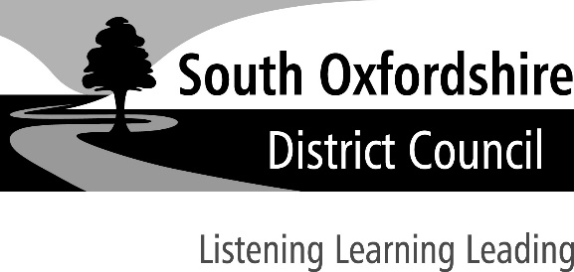
SECTION A – Details of society applying for registration

- Name of society

- Address (including postcode) of office or head office of society

- Telephone number of society

- Please state the purpose(s) for which the society is established and conducted

- If the society is a registered charity, please give the society’s unique charity registration number

- Has the society held an operating licence under the Gambling Act 2005 in the period of five years ending with the date of this application? Yes No

- If the answer to question 6 is ‘Yes’, has the operating licence been revoked in the period of five years ending with the date of this application? Yes No

- If the answer to question 7 is ‘Yes’, please state the reasons for revocation and enclose a copy of the notice of revocation if one is available

- Has the society applied for and been refused an operating licence in the period of five years ending with the date of this application? Yes No

SECTION B – General information about person applying on behalf of society

- Name

- Capacity

- Address (including postcode)

- Daytime telephone number

SECTION C – Contact details for correspondence associated with this application

- Please tick one box as appropriate to indicate address for correspondence in relation to this application:
Address in section A Address in section B Address below

Address (including postcode)

Telephone number

Email address

SECTION D – Declaration

15. Please complete the following declaration and checklist: I [Full Name]
- make this application on behalf of the society referred to in Section A and have authority to act on behalf of that society.
- enclose payment of the registration fee of £40.
- confirm that, to the best of my knowledge, the information contained in this application is true. I understand that it is an offence under section 342 of the Gambling Act 2005 to give information which is false or misleading in, or in relation to, this application.

Signature

Date

Capacity

Note to societies applying for registration:

The application will be refused if in the period of five years ending with the date of the application:
- an operating licence held by the society has been revoked under section 119(1) of the Gambling Act 2005, or
- an application for an operating licence made by the society has been refused.

The application may be refused if the local authority think that:
- the society is not a non-commercial society,
- a person who will or may be connected with the promotion of the lottery has been convicted of a relevant offence, or
- information provided in or with the application is false or misleading.

