South Oxfordshire District Council
Delivering Corporate Plan Priorities:
Strategic Performance Report
Quarter 1 2021/22

Background:
- The Council monitors performance and progress towards achieving the aim and priorities set out in the Corporate Plan

- This report provides a strategic overview of the performance for Q1 (1 April to 30 June 2021), focusing on the activity to deliver the corporate priorities in the new South Oxfordshire District Council Corporate Plan 2020-24.

- In addition to providing a performance update and assurance against the delivery of the Council’s six strategic themes in the Corporate Plan, this report will also provide any strategic context relevant to the Council’s operations and, given the significant impact of Covid-19 on communities, services and staff, the report will include a section on Covid-19 response and recovery.

- This report is the first iteration, and it is expected that it will evolve in line with the new approach to Performance Management being embedded in the Council, as well as from feedback from senior officers and Members.

Strategic Context

The impacts of the Covid-19 pandemic continued to have far-reaching implications for the Council and our communities during Quarter 1 – 01 April to 30 June 2021. Although the pandemic has created an unprecedented challenge for the Council, we have responded to the needs of our communities, whilst successfully starting to deliver on our commitments within the South Oxfordshire District Council Corporate Plan – a forward-looking plan which is the start of a new direction to 2024.
This Quarter included significant easing of restrictions as part of the Government’s roadmap steps 2 and 3, increasing many residents’ social freedoms. However, those who are clinically extremely vulnerable, or those who feel the level of risk is too high, have not been able to access these new social freedoms, which may create the risk of social isolation for some residents, with consequences for both mental and physical health. This Quarter has also seen the continuation of the biggest NHS vaccination programme in health service history, with over half of adults under 30 having been vaccinated against Covid-19 by 27 June 2021. The impact of the pandemic on resident wellbeing remains a focus for the Council in Quarter 2 and beyond.
As the Council’s focus has shifted from the immediate response to the pandemic, to longer term planning for recovery, our work has included delivering on our commitment on investment that rebuilds our financial viability. This Quarter we have responded to opportunities to influence HM Government for an improved financial settlement for Councils, to ensure longer term financial and service sustainability. A consultation response was submitted on the future of the New Homes Bonus (which included proposals for a new funding formula), the outcome of which will be monitored over the upcoming Quarter.
The national reopening of sports facilities, retail and hospitality sectors and cultural centres from 26 June, the reopening of Cornerstone in Quarter 2, and potential income generation opportunities from projects to be delivered in future Quarters – such as the Strategic Property Review - will also be important aspects to ensuring our future financial viability.

Theme 1. Protect and restore the natural world

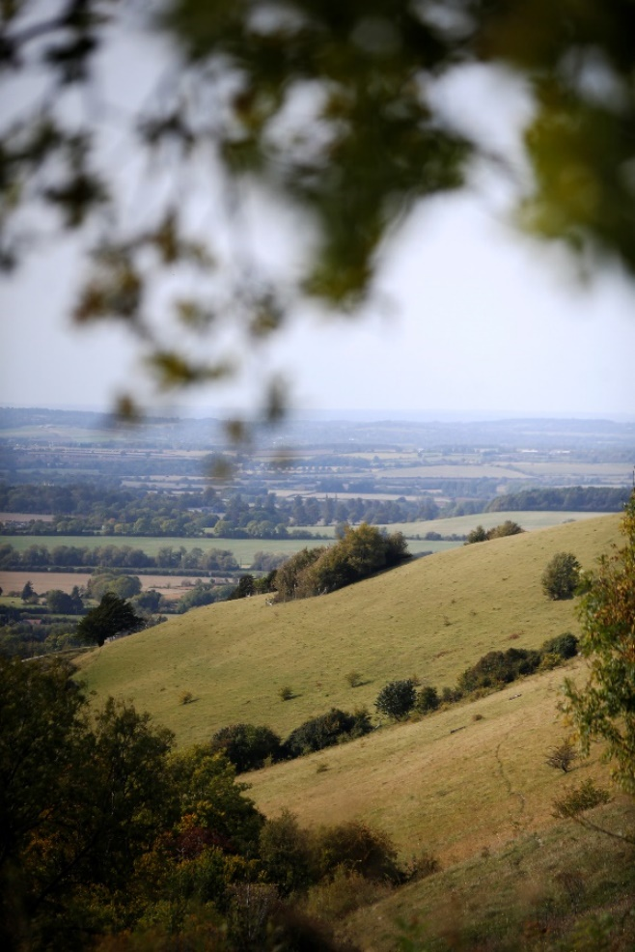
Strategic Lead – Suzanne Malcolm – Deputy Chief Executive – Place
Why?
South Oxfordshire is a largely rural district, including parts of two Areas of Outstanding Natural Beauty (AONBs) and the Oxford Green Belt, as well as a long stretch of the River Thames. The natural world is proven to provide benefits to both mental and physical health, as well as having its own intrinsic value, and it needs our protection.
So:
We will respect and protect our natural environment, especially our Areas of Outstanding Natural Beauty (AONBs) and other nature rich areas. We will champion the opportunity to restore our natural world in both biodiverse and bio-depleted areas through nature recovery networks and other means. We will connect urban communities to their local green spaces and restore nature to urban environments.
Key Activity in Q1:
To deliver our ambition to respect and protect our natural environment, South Oxfordshire has continued to work with Thames Valley Environmental Records Centre to collate and map all biodiversity data within Oxfordshire. This entails collaborating with a variety of specialist agencies and recording groups to produce updates for the Council’s GIS system (this occurs three times per year). The Council also commissions an Annual Monitoring Report (AMR) which tracks changes in the status of 5 different indicators of the health of ecosystems (this covers both habitats and species).

An elected member group, the Biodiversity Working Group, has been created. This new group will report into the Climate and Ecological Emergency Advisory Committee (CEEAC), and support them to shape and prioritise the projects included under this theme that are subject to future funding.

To further our ambition of championing the opportunity to restore our natural world, we are working with neighbouring local authorities to establish a Local Nature Partnership for the county. The aim of the Partnership is to radically enhance nature, promote its positive impact on our climate and ensure that it is prioritised. In Quarter 1 we collectively started recruiting Partnership Board members and exploring funding options.

To enable us to connect urban communities to their local green spaces and to restore nature to urban environments, South Oxfordshire has been liaising with the Earth Trust and Didcot Town Council to initiate a partnership approach to accessing open space at Great Western Park. Officers from the Didcot Garden Town team organised a site visit with the Earth Trust’s programme manager to help facilitate this work.

The Council have also joined the Visit River Thames association and renewed its membership of Experience Oxfordshire to promote the natural environment to both residents and visitors. In addition, we have secured representation on the boards of both Tourism South East and Visit River Thames. Reviews of the Visit Thames, Experience Oxfordshire and Tourism South East websites were undertaken to complement this work and ensure the best approach was taken.

Performance Measures
Corporate Plan ID | Stated Aim/Project description | Measure | Cabinet Lead | Officer Lead | Performance Update
PRN1 | With partners, promote in-depth mapping and surveying of ecosystems across the district, planning for restoration of the natural world and working closely with landowners and specialist agencies | Narrative report to include information on work with partners, and Habitat and Species data + changes/trends on a 12month basis. | Cllr Sue Cooper | Adrian Duffield | South Oxfordshire works with the Thames Valley Environmental Records Centre to collate and map all biodiversity data within Oxfordshire. This entails collaborating with a variety of specialist agencies and recording groups to produce updates for the Council’s GIS system (this occurs three times per year). South also commissions an Annual Monitoring Report (AMR) which tracks changes in the status of 5 different indicators of the health of ecosystems (this covers both habitats and species).
PRN2 | Celebrate, protect and enhance our natural assets, including the River Thames and the AONBs and their setting, promoting our rural district for tourism, leisure and wellbeing | Narrative report to include information on work to manage natural assets and ANOBs (both internally and with partners) | Cllr Andrea Powell | Chris Traill | HM Government’s Tourism Recovery Plan was promoted through South and Vale Business Support newsletters and on social media. The Council joined the Visit River Thames association and renewed its membership of Experience Oxfordshire. Furthermore, South is represented on the boards of both Tourism South East and Visit River Thames.  Reviews of the Visit Thames, Experience Oxfordshire and Tourism South East websites were also undertaken to ensure that they were up to date (www.experienceoxfordshire.org, www.tourismsoutheast.com, www.visitthames.co.uk).
PRN3 | Encourage the use of natural processes to combat risks arising from climate change, such as meadows and trees to reduce flooding | Narrative report to include direct and indirect information on use of natural processes to combat risks of climate change. This should include new policy development and direct activity undertaken by the Council. | Cllr Sue Cooper | Chris Traill | The Council is consolidating its approach to the adoption and management of significant open spaces at Great Western Park. This is to enable best practices to be utilised and to help combat climate change.

Corporate Plan ID | Stated Aim/Project description | Measure | Cabinet Lead | Officer Lead | Performance Update
PRN4 | Recognise and support the vital role of farming in economic and ecosystem resilience, local food provision and the recovery of soils and natural processes | Narrative report on activity undertaken with partners to encourage and support the vital role of farming in economic and ecosystem resilience (where possible, although this may be implicitly included in the information above). | Cllr Sue Cooper | Chris Traill | No progress reported Q1 2021/22
PRN5 | Call for the establishment of a Local Nature Partnership for Oxfordshire to promote an ambitious nature recovery programme, including tree and meadow planting, rewilding and providing habitats for wildlife including wildlife corridors | Narrative report - accepting that much of the activity to support PRN3 will be relevant here. | Cllr Pieter-Paul Barker | Harry Barrington-Mountford | A Local Nature Partnership (LNP) for Oxfordshire is in the process of being established. The aim of the Partnership will be to radically enhance nature, to promote its positive impact on our climate and ensure that it is prioritised. LNP Board members are currently being recruited and funding options explored. The aim is to have the Board up and running by the end of September 2021.
PRN6 | Work in partnership with the Earth Trust, Chilterns Conservation Board, North Wessex Downs AONB, the Environment Agency and others to improve access to green spaces in and around our towns, reinforcing access to nature as a priority for community wellbeing | Narrative report on activity with partners (including those named, and others), with a particular focus on work supporting the link between green spaces and community wellbeing. | Cllr Pieter-Paul Barker | Chris Traill | South Oxfordshire is currently liaising with the Earth Trust and Didcot Town Council to initiate a partnership approach to accessing open space at Great Western Park. To help facilitate this work, officers from the Didcot Garden Town team organised a site visit with the Earth Trust’s programme manager.

Theme 2. Openness and accountability

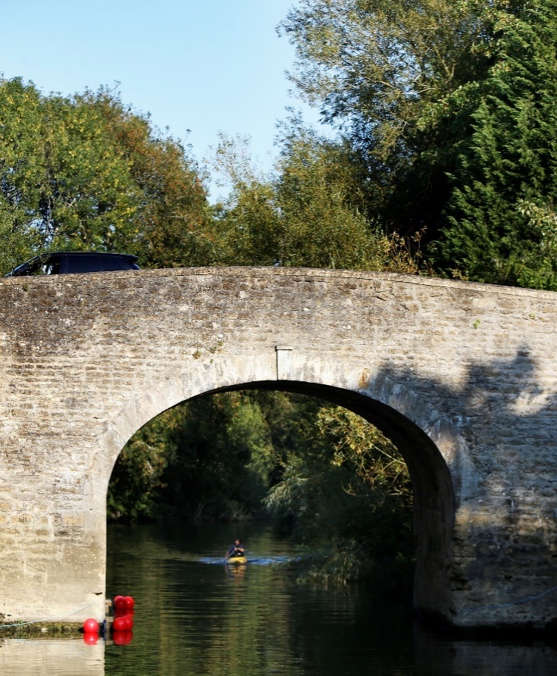
Strategic Lead – Adrianna Partridge – Deputy Chief Executive –
Transformation and Operations

Why?

The complexity of modern society and local government structures can be hard to navigate. Many services are delivered as part of external partnerships, so it can be hard for residents to see what we do and how we do it. There are some groups within our district with whom we have little engagement or interaction, so the diversity of our district is not always recognised and supported.

So:

We will maintain and improve high levels of satisfaction with the services we provide and will reach out to all sectors and age groups to foster a culture of openness, participation, and representation. We will use our influence to champion inclusion, diversity and transparency across all elected and unelected bodies in our region. We will empower and invest in our staff and conduct our operations with the highest level of integrity and accountability.

Key Activity in Q1:

To better champion inclusion and diversity within the Council and across our district, work is underway on a Diversity & Inclusion Strategy that will ensure the Council is inclusive in its staff recruitment, its representation, and its service provision.

The live streaming and recording of meetings has been highlighted as a key part of enhancing openness and accountability in our democratic decision-making process. In Quarter 1 of 2021/22 all public Council meetings were livestreamed and then put up on the Councils’ YouTube Channel, where they remain available for the public to view:
https://www.youtube.com/c/SouthandValeCommitteeMeetings.

Changes to the legal provisions for holding remote meetings and the return to face-to-face meetings present the Council with various challenges that will have to be met if we are to continue to make meetings accessible online, live, or recorded. We have now returned to in-person meetings where this is required but continue to allow remote public and officer participation. In this mixed approach we are seeking to maintain our high standards for openness, accountability, and inclusivity.

To meet our commitment to openness and to encourage inclusiveness, engagement and participation, regular strategic communications meetings are held with the Cabinet Member and the Leader of the Council to ensure the active communication of decision making and outcomes. The Communications team seek to engage across various media platforms and outlets. Work is also under way on the production of bespoke communications plans for each of South Oxfordshire’s corporate priorities.

In line with our commitment to engage effectively with residents, Parish Councils and other community organisations, the Council has run Town and Parish Forum events on Assets of Community Value and Climate Change, both of which garnered a lot of positive feedback and ideas for future events. A programme of further engagement events is currently being developed.

The Census 2021 was completed this Quarter. The Council worked collaboratively with the Office for National Statistics on ensuring strong engagement and uptake amongst our communities. The household response rate within South Oxfordshire exceeded 90%. Quality assurance and review of the data is expected to take place in the next Quarter.

Performance Measures

Corporate Plan ID | Stated Aim/Project description | Measure | Cabinet Lead | Officer Lead | Performance Update
OA1 | Enhance trust and accountability in democratic decision-making, including live-streaming and recording of meetings, ensuring full accessibility of facilities and monitoring progress in an open and transparent way | Narrative update to include information on the performance management framework, communications update on Cabinet/Council decisions, IAG around the operations/activity of the Council  % of Public Council meetings within 12 months available online | Cllr Andrea Powell | James Carpenter | During Q1 2021/22, all Council meetings were livestreamed before being uploaded to YouTube. As the legal provisions for holding remote meetings have altered, maintaining this 100% performance will be challenging.  Regular strategic communications meetings are held with the Cabinet Member and the Leader of the Council to ensure the active communication of decision making and outcomes.
OA2 | Ensure that Council departments work collaboratively to deliver best outcomes for residents | Narrative report detailing significant, non-recurring examples of inter-departmental working which have secured concrete outcomes for residents | Cllr Andrea Powell | James Carpenter | Customer services staff have provided a good exemplar of interdepartmental working this Quarter by initiating a process that enabled them to take payments on behalf of a number of other Council teams including bulky waste, animal welfare and on a temporary basis car parking permits. This has enabled customers to continue to access these paid for services quickly whilst the cash office has been closed whilst that we continue to deliver better outcomes for customers.
OA3 | Embed an organisational culture that celebrates diversity, inclusion, and respect | Narrative report on work undertaken to celebrate diversity, inclusion, and respect. Should include standard recurring activity, one off supporting activity. This should be a joint report primarily from HR/Comms but include comments from others/ | Cllr Maggie Filipova-Rivers | James Carpenter | Work on the creation of the Diversity & Inclusion Strategy is underway. Discussions have been held with portfolio holders and lead members on its potential look and content. In addition, a Corporate Equalities Action Plan is also being produced to complement and put into practice the aims of the Strategy. We expect to have an outline of the Diversity & Inclusion Strategy ready for further conversations with Councillors in late July. The Cabinet Approved a new Diversity Calendar.
OA4 | Apply good governance and transparency in all our working and decision-making, exploring optimal structures and mechanisms for best practice in local government | Narrative report on significant change initiatives which have resulted in restructures/new processes to deliver local govt services. | Cllr Sue Cooper | Margaret Reed | During Q1 2021/22, South returned to in-person meetings where required. We are, nevertheless, continuing to allow remote public and officer participation. In addition, informal virtual meetings are continuing where they are best suited to the purpose of the items/topics being discussed.
Corporate Plan ID | Stated Aim/Project description | Measure | Cabinet Lead | Officer Lead | Performance Update
OA5 | Engage effectively with residents, Parish and Town Councils and other community organisations, using plain English in our communications and using appropriate methods and technologies to ensure equal and fair access for all | Narrative report on activities communications/engagement specific activities | Cllr Maggie Filipova-Rivers | James Carpenter | As part of their business-as-usual activities, the Communications team continue to seek to engage across various media platforms and outlets. In recent months, the Council has run Town and Parish Forum events on Assets of Community Value and Climate Change. A programme of further engagement events is currently being developed.  Work is also under way on the production of communications plans for each of South Oxfordshire’s corporate priorities.  The upcoming publication of Census data will help to inform our equalities and diversity approach. It will also help us to better understand the needs of harder to reach groups and allow us to improve our engagement approach accordingly.

Theme 3. Action on the climate emergency

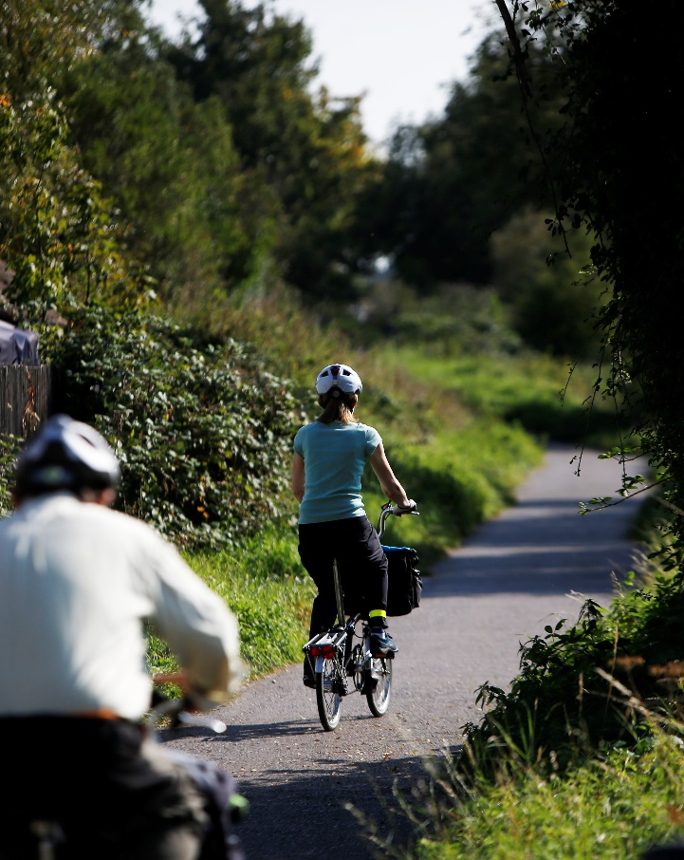
Strategic Lead – Suzanne Malcolm – Deputy Chief Executive – Place
Why?

The greatest challenge we face as a society is the Climate Emergency and our ability to adapt our lives and our behaviours to ensure a safe and resilient future. While statements and targets are welcome, the challenge for our district is to take action, transform our operations and inspire our residents and businesses to do the same. Aspects of our lives will need to change, but we have a duty to make this transition fair for all parts of society.

So:

We will show leadership by developing and implementing a climate change programme to make the Council net carbon neutral by 2025. We will help our communities to plan a fair transition to a future that will be defined by climate change.

Key Activity in Q1:

As the climate emergency compels us to change aspects of our lives, the Council is working to enable the delivery of increased housing stock while at the same time meeting our ambitious targets on carbon reduction.

The Berinsfield Garden Village project is an important part of South Oxfordshire’s plan to deliver increased housing stock. The Council was recently successful in securing additional funding from Homes England for the project, to meet our commitments on carbon reduction and to provide leadership and support for residents and businesses across the district.

With the need for the Council to show leadership and a positive example in developing a fair transition to a low carbon future, in Quarter 1 the Council obtained a final options appraisal on the potential to develop PassivHaus affordable homes at 116-120 Broadway, Didcot.

In Quarter 1 the Council also worked to submit a bid into HM Government’s Levelling Up Fund to deliver a cycleway from Berinsfield to Oxford. This scheme is now being considered for tranche 3 funding by Oxfordshire County Council and could be a significant improvement to cycling infrastructure and connectivity in the district.

Promoting and enabling waste minimisation and encouraging more sustainable practices is also an important strand of the Council’s work to tackle the climate emergency. In 2019/20 South Oxfordshire’s recycling rate was 64%. It is consistently one of the top performing districts in the country. In order to further reduce overall waste, we have launched a new webpage: “reducing your waste and increasing your reuse” (https://www.southoxon.gov.uk/south-oxfordshire-district-Council/recycling-rubbish-and-waste/reducing-your-waste-increasing-your-reuse/). This outlines some of the actions that residents can take to reduce consumption and increase recycling.

The Economic Development team held ‘circular economy’ and ‘sustainable construction workshops’ for local businesses. These workshops allowed for the sharing of information, best practice, and innovative thinking.

The 2021 Air Quality Annual Status Report has been submitted to Defra. This report covers the 2020 period and sets out progress on the Air Quality Action Plan. We are currently awaiting feedback prior to publication.

Throughout Quarter 1, the Climate Action team have worked with colleagues across Council departments to ensure that our commitments on the climate emergency are reflected in the work we do. The team have reviewed plans, provided insight and expertise, and advised colleagues on how projects can be made as climate friendly as possible, with all formal reports now having a “climate implications” section. This engagement with teams across the Council contributes to the fact that tackling the climate emergency is an important factor across several themes in this report. It also reflects the fact that action on climate change must be wide ranging if we are to meet the scope of our ambition in this area.

The Council is moving forward in the development of the Climate Action Plan and will be co-creating the plan with service areas to ensure the Climate Emergency is fully embedded into all service plans.
Performance Measures
Corporate Plan ID | Stated Aim/Project description | Measure | Cabinet Lead | Officer Lead | Performance Update
ACE1 | Achieve our own zero carbon target by 2025 and support others to achieve the district target of zero carbon by 2030 | Narrative report on strategic projects which will help to deliver net zero carbon for 2025/2030. This should be split between Council specific and District specific activities. | Cllr Sue Cooper | Chris Traill | As part of the Berinsfield Garden Village we are looking to understand how the Council can deliver/support delivery of housing using modular, self-build and eco-friendly techniques.
ACE2 | Develop an annually approved climate emergency programme and adequately finance it | Quantitative measure - delivery of an annual CEP Y/N | Cllr Sue Cooper | Harry Barrington-Mountford | A Climate Action Plan for South Oxfordshire is being developed.
ACE3 | Deliver Council-owned net-zero homes and use grants, planning policy and advocacy to ensure the same standards throughout the district | Narrative Update on the current activities which will result in the delivery of Council owned homes (and details of those homes where possible) | Cllr Robin Bennett | Chris Traill | South Oxfordshire has obtained a final options appraisal on the potential to develop PassivHaus affordable homes at 116-120 Broadway, Didcot. The next stages will be to procure a design team and achieve a planning submission.
ACE4 | Promote and encourage behavioural change with informational campaigns and leading by example | Narrative update to include the number of communications campaigns undertaken which promote/encourage behavioural change (with examples). | Cllr Andrea Powell | James Carpenter | The Council has continued its regular communication activity to support behavioural change, a particular highlight in this period is the work undertaken to promote ‘Earth Day’, this focused on highlighting opportunities for energy efficiency and volunteering opportunities with climate action groups

Corporate Plan ID | Stated Aim/Project description |  |  | Measure |  | Cabinet Lead |  | Officer Lead | Performance Update
ACE5 | Take positive action on single-use plastics, air quality improvement measures and sustainable transport |  |  | Suggested combined narrative update on Comms relating to single use plastics/comms relating to AQ initiatives and metrics relating to AQ (with an appreciation that this data will be skewed in 2020 due to lockdown(s) |  | Cllr David Rouane |  | Liz Hayden | South Oxfordshire provided submissions to the Extended Producer Responsibility and Deposit Return Scheme consultations being run by Defra. An initial draft of our proposed response to the Consistency of Collections consultation has been circulated for comment. The key issues that this considers are:  1. The obligation to collect food waste  2. A proposal to offer a free garden waste service to all households  3. How our recyclable material is collected from households and whether this needs to be separated  4. Recycling credits  5. The type of caddy liner used in food waste bins
ACE6 | Mitigate climate change through planning and land use, enhancing biodiversity on our own land and strengthening the planning system to enforce environmental standards |  |  | Narrative update to focus on planning initiatives which support the potential deliverables where possible (primarily the development of the joint 2041 Local Plan, the joint Design Guide and carbon reduction in planning  (DES8/10) |  | Cllr Anne-Marie Simpson |  | Adrian Duffield | Annual Target  DES10 Advice Note published in May
ACE7 | Promote the circular economy (reduce, re-use and recycle), including in our waste management contracts |  |  | Narrative measure on comms activity relating to waste/recycling  Quantitative information on recycling rate, contamination rates, % of residual waste to landfill |  | Cllr David Rouane |  | Liz Hayden | South Oxfordshire’s recycling rate was 64%. It is consistently one of the top performing districts in the country.  In order to further reduce overall waste, we have launched a new webpage “reducing your waste and increasing your reuse” – https://www.whitehorsedc.gov.uk/vale-of-white-horse-district-Council/recycling-rubbish-and-waste/reducing-your-waste-increasing-your-reuse/  This outlines some of the actions that residents can take to reduce consumption and increase recycling.
Corporate Plan ID |  | Stated Aim/Project description | Measure |  | Cabinet Lead |  | Officer Lead | Performance Update
ACE8 |  | Support and encourage local businesses to respond to climate change and nature recovery | Narrative update on the influencing work undertaken to support and encourage local businesses relating to climate change and nature recovery |  | Cllr Robin Bennett |  | Chris Traill | The Economic Development team held a ‘circular economy’ workshop that was attended by 34 people. They have also arranged a ‘Sustainable Construction’ workshop to be held on 14 July 2021. This is intended to showcase local examples of lower-carbon construction, as well as providing an opportunity for attendees to hear from Bioregional – a charity and social enterprise committed to developing more sustainable ways of living.  In addition, the team went to Greentech’s One Planet Living update in order to better understand the challenges facing Oxfordshire in reaching net zero.  HM Government’s new SME Climate Hub is being promoted in our business newsletters and through social media.
ACE9 |  | Promote waste minimisation initiatives such as Repair Cafés | Unless specific activity relating to Repair Café's and Freecycle can be reported on, suggest that this is covered in previous narratives |  | Cllr David Rouane |  | Liz Hayden | In order to further reduce overall waste, the Waste team have launched a new webpage “reducing your waste and increasing your reuse” – https://www.whitehorsedc.gov.uk/vale-of-white-horse-district-Council/recycling-rubbish-and-waste/reducing-your-waste-increasing-your-reuse/  This outlines some of the actions that residents can take to reduce consumption and increase recycling.
ACE10 |  | Work with Oxfordshire County Council to build on our commitment to active travel including walking, public transport and cycling infrastructure | Narrative update on work with  Oxford County Council  Optional Quantitative metrics on the amount of new footpaths/cycle paths |  | Cllr Pieter-Paul Barker |  | Chris Traill | The Didcot Garden Town team has agreed to lead on the Local Cycling and Walking Infrastructure Plan for Didcot and its environs. They will be supported in this by Oxfordshire County Council. As part of this project, they have been actively working to update the Oxfordshire Infrastructure Strategy to include active travel projects.  A bid to fund a cycleway from Berinsfield to Oxford was submitted to the Levelling Up Fund. This scheme is now being considered for tranche 3 funding by the county.

Theme 4. Improved economic and community wellbeing

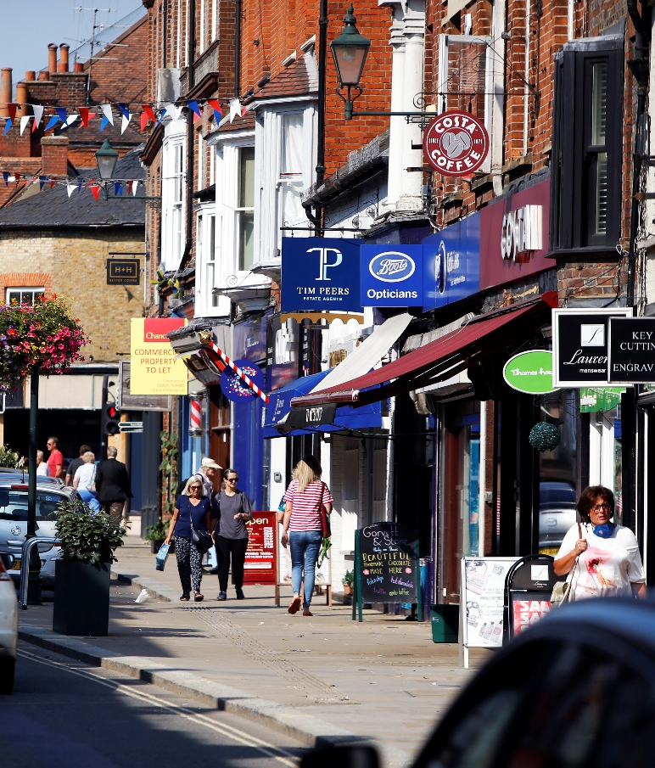
Strategic Leads – Suzanne Malcolm - Deputy Chief Executive – Place
Adrianna Partridge – Deputy Chief Executive Transformation and Operations

Why?

South Oxfordshire has a large number of small and micro businesses and is well placed to adapt to changes in the economy, but support will be needed for it to remain a healthy and vibrant place to live and work. The Coronavirus pandemic has shown the strength of the community but there are areas of isolation and deprivation in our district, and the benefits of access to culture, leisure, and community for all has been made clear.

So:

We will reimagine our high streets, helping independent small businesses to thrive and to encourage cultural well-being for all. We will encourage clean local economic development and support our business hubs, centres of scientific excellence and our educational establishments to become leaders in sustainable technology, innovation, and enterprise. We will help our community groups to strengthen cohesion, reduce social isolation and tackle areas of deprivation.

Key Activity in Q1:
To further our ambition for improved economic and community wellbeing, in Quarter 1 we have updated our Community Infrastructure Levy (CIL) spending strategy to accelerate the delivery of local infrastructure improvements and allocate funding to achieve the best outcomes for residents of the district. Quarterly CIL and Section 106 expenditure/income reports are now being provided to Cabinet and the CIL charging schedule is currently being reviewed by the Planning team. Work is underway to prioritise previously identified potential projects by CIL criteria and, when this is completed, it will be presented to Members to allocate funding.
£2.7 m
IN ADDITIONAL RESTRICTIONS GRANTS
To deliver on our commitment to reimagine our high streets, helping independent small businesses to thrive and to encourage cultural well-being for all, we have provided advice on access to grants, training, and diversification programmes to help local businesses build agility and resilience post Covid-19. We have paid £2,719,811 to 901 businesses from the Additional Restrictions Grant Round 2, and £842,401 was given to 864 businesses through the Additional Restrictions Remobilisation Grant. We supported 839 users to access the iDEA Programme, to support the development of skills within our local businesses and received 800 e-mail enquiries seeking our support. There are 2,456 subscribers to our newsletter, and the South and Vale Business Support website has been visited more than 1,400 times each month this Quarter.
£842,401
IN REMOBILISATION
GRANTS
We have attended Joint Oxfordshire Business Support (JOBS) meetings to help plan for the county’s economic recovery. The Council supported work to fill empty high street units – receiving 43 expressions of interest from occupiers even though there are only 8 available units.
Littering patrols have been introduced in Didcot, Henley, Wallingford and Thame. Although the emphasis has been on education, unless an offence is witnessed, 5 Fixed Penalty Notices have been issued. There have been 185 fly tipping incidents reported, a reduction of 36% on the same period last year. The Council undertook prosecutions which are awaiting court dates, and 2 Fixed Penalty Notices were issued. 11 ‘Duty of Care’ Inspections have been undertaken and a further nine warning letters issued. There were 102 reports of abandoned vehicles, 36 vehicles were not on site when visited, 37 not considered abandoned, 2 vehicles removed, with the remaining still under investigation.
1,400
VISITS TO BUSINESS SUPPORT WEBSITE
The Department for Transport have signed off an application to introduce civil parking enforcement as a district responsibility. A Cabinet report is being drafted to confirm the changes required in the Council’s off-street car park orders. Oxfordshire County Council are identifying locations for on-street parking bays. A soft launch of civil parking enforcement is being planned for the district, so that people can learn about the changes and be encouraged to park responsibly. It is currently anticipated that the transition will start in November 2021 with the new system in place for January 2022.
2
WASTE CRIME PROSECUTIONS
In order to support our ambition to learn the lessons from the COVID-19 experience and enable increased homeworking, we are collaborating with Better Broadband for Oxfordshire to respond to residents’ questions about the accessibility of full fibre and concerns about the health implications of 5G masts. South Oxfordshire also submitted comments to HM Government’s consultation on permitted development rights to install 5G masts. The Business in Rural Oxfordshire project (led by AirBand) is still on track for Q2 despite some delays in Quarter 1.
43
EXPRESSIONS OF INTEREST FOR 8 EMPTY UNITS

Performance Measures
Corporate Plan ID | Stated Aim/Project description | Measure | Cabinet Lead | Officer Lead | Performance Update
ECW1 | Partner with regional agencies to ensure economic recovery, quality employment, thriving businesses and vibrant communities, avoiding the blight of “dormitory towns” | Narrative report on work with partners in this area  Quantitative metrics relating to employment rates (trends, actuals) - unemployment rate, trajectory/trend, earnings information | Cllr Pieter-Paul Barker | Chris Traill | Officers have attended the Joint Oxfordshire Business Support meetings to plan the economic recovery from the pandemic.  The space project team have also been working on filling empty high street units. The Council has received 43 expressions of interest even though there are only 8 available units.
ECW2 | Provide advice on access to grants, training and diversification programmes, helping local businesses to build agility and resilience | Quantitative measures - number of businesses we engage with, social media hits, newsletter subscribers, clickthrough rate, numbers of business grants awarded | Cllr Robin Bennett | Chris Traill | The focus in Q1 2021/22 was on the delivery of Covid-19 discretionary business grants. During the Additional Restrictions Grant Round 2, we paid out £2,719,811 to 901 businesses. In addition, £842,401 was given to 864 businesses through the Additional Restrictions Remobilisation Grant.  In terms of skills, 839 users have accessed the iDEA Programme.  The Council received 800 e-mail enquiries seeking support.  There are 2,456 subscribers to our newsletter and the South and Vale Business Support website is visited more than 1,400 times each month.
ECW3 | Plan for communities connected by walking & cycling networks, with sustainable, accessible and affordable public transport and reliable Broadband, learning the lessons from the Covid-19 experience and enabling more home-working. | Narrative update on work support reliable broadband (where possible)  Narrative update on transport initiatives  Quantitative - new footpath/cycle paths delivered | Cllr Anne-Marie Simpson | Chris Traill | During Q1 2021/22, the Council worked with Better Broadband for Oxfordshire to respond to residents’ questions about the accessibility of full fibre and their concerns about the health implications of 5G masts. South Oxfordshire also submitted comments to HM Government’s consultation on permitted development rights to install 5G masts.  The Business in Rural Oxfordshire project (led by AirBand) has had to delay delivery to some areas. It is still, however, on track for Q2.

Corporate Plan ID | Stated Aim/Project description |  | Measure | Cabinet Lead | Officer Lead | Performance Update
ECW4 | Launch a new community wellbeing strategy to encourage and support culture, leisure and the arts |  | Approval/Launch of 'Community Wellbeing Strategy' Y/N (document should encompass large parts of information above) | Cllr Maggie Fillipova-Rivers | James Carpenter | No progress reported Q1 2021/22
ECW5 |  | Use our planning powers to preserve our valuable green spaces, particularly in urban areas | Number of Neighbourhood Plans implemented/green spaces secured | Cllr Anne-Marie Simpson | Adrian Duffield | Totals will be reported annually, however during May 7 Neighbourhood Plans adopted
ECW6 |  | Work with our communities to maximise Community Infrastructure Levy funds and to allocate these to achieve best outcomes for residents in the District | Narrative update about work in this area to include detail of new CIL spending strategy, communication with parishes  Quantitative elements - CIL Spend broken down by type, by parish | Cllr Robin Bennett | Chris Traill | The CIL spending strategy was updated in December 2020. It came into force on 1 April 2021.  Quarterly CIL and S106 spend/income reports are provided to Cabinet Members.  The CIIL charging schedule is currently being reviewed by the Planning team.
ECW7 |  | Take enforcement action on fly-tipping and dog fouling | Small narrative on Fly Tipping/dog fowling activity (with Comms input on any campaigns)  Qualitative data on fly tipping - what we collect, where from, how much, nature of enforcement action undertaken, hotspot map. | Cllr David Rouane | Liz Hayden | 185 fly tips were recorded in South Oxfordshire during Q1 2021/22. This was a 36% reduction on the same period last year.  Littering patrols restarted in May 2021. The emphasis is on education – unless an offence is actually witnessed. The patrols resulted in five fixed penalty notices being issued.  There were 102 reports of abandoned vehicles in Q1 2021/22. Of these: 36 were not on site at the time officers visited, 37 were not considered abandoned and 2 were removed. The remainder are still under investigation.  Two waste prosecutions were brought against individuals between Apr-Jun 2021 – seven waste crime prosecutions are still awaiting court dates. In addition, two fixed penalty notices were issued. There were also eleven ‘Duty of Care’ inspections and the delivery of a five none warning letters.

Corporate Plan ID | Stated Aim/Project description | Measure | Cabinet Lead | Officer Lead | Performance Update
ECW8 | Work with local partners to introduce civil parking enforcement as a district responsibility | Narrative update on progress | Cllr David Rouane | Liz Hayden | The Department for Transport have signed off on the application to introduce civil parking enforcement within South Oxfordshire. A joint press release has been issued to this effect.  Officers are currently drafting a cabinet report to confirm the changes required in the Council’s off-street car park orders, while Oxfordshire County Council are identifying locations for on-street parking bays to charge.  We are planning for a soft launch of civil parking enforcement, so that people can learn about the changes and be encouraged to park responsibly. It is proposed that the transition will start in November 2021 with the move to the new system scheduled for January 2022.

Theme 5. Homes and infrastructures that meet local needs

Strategic Lead – Suzanne Malcolm – Deputy Chief Executive – Place
Why?
The average price of a home is many times higher than the average salary, particularly for the young, and renting is also expensive. The pressure to build new homes in our district sometimes outweighs local wishes. Infrastructure like roads, schools and GP surgeries have not kept up with housing development. Too many houses being built today are not fit for a low carbon future.
So:
We will strive to ensure that new homes and infrastructure in South Oxfordshire meet local needs, are sustainable, zero carbon in their build and operation, and high quality in design. We will provide homes that people can afford to live in. New developments will be accessible with walking, cycling and public transport a priority. Neighbourhood plans and local participation will sit at the heart of our planning process. We will work with partners to ensure that development is appropriate for our communities.
Key Activity in Q1:
Our Garden Town and Village initiatives for Didcot and the Berinsfield area are at the forefront of our progress to deliver the homes and infrastructures that people need. The Didcot Garden Town Advisory Board, and three sounding boards for residents, businesses and Parish Councils are continuing to meet regularly. This has led to the establishment of a Didcot-based business leadership group.
We are working towards transforming Berinsfield into a thriving Garden Village with improved facilities developed in line with the community’s needs and aspirations. Corporate governance is currently being established for the project and discussions with the local landowner and Homes England are ongoing, with bi-monthly steering group meetings being facilitated by officers.
A Berinsfield Garden Village website has been set up and new Garden Village logos are being developed for the community to review. The Garden Village team will be attending local events to promote interest in the project and to sign people up for news and information updates.
£120,000
HOMES ENGLAND FUNDING AWARD
We have strengthened the capacity of our Insight & Policy service and implemented a new process to support signposting and access to external funding opportunities. This new approach has supported the submission of Levelling Up Fund and exploring the potential for Public Sector Decarbonisation Fund bids this Quarter. Homes England have also recently awarded the Garden Town £120,000 in capacity funding.
A key challenge for South Oxfordshire in terms of housing is delivering new homes which meet local needs. During April and May 2021, 65 properties were reported to have been delivered in the district. In comparison to Q4 2020/21, more of the properties completed have contained 3+ bedrooms and more have been available for shared ownership – it should be noted that over the life of a development, different dwelling and tenure types will be delivered at varying rates, depending upon the developer’s build programme.
65
NEW HOMES DEVELOPED

In addition, a final options appraisal has been obtained on the potential for developing PassivHaus affordable homes at 116-120 Broadway, Didcot. The next stage will be to procure a design team and achieve a planning submission. This is also an exciting development towards the Tackling the Climate Emergency theme.
We are delivering a range of work to eliminate homelessness and rough sleeping in South Oxfordshire. To help further this, the Council recently adopted the Oxfordshire’s Homelessness and Rough Sleeping Strategy. This prioritises homelessness prevention, rapid response, ensuring the right home in the right place, and a person-centred approach to homelessness. Moreover, we have nearly completed the second phase of our Housing First project. This is designed to assist entrenched rough sleepers off the streets by offering them intensive, tailored and open-ended support without any pre-conditions

In order to encourage the retrofit of our existing housing stock for low-carbon performance and to eliminate fuel poverty, South Oxfordshire (in conjunction with Vale of White Horse) have established a joint retrofit task and finish group. This will review the retrofit landscape across both districts and make recommendations for a way forward. The group have already met with key partners to understand their experiences and perspective on this topic and a report, suggesting potential ways forwards, has been written. Work is currently underway on a paper that will be presented to the Councils’ Scrutiny Committees.
To further our commitment that new developments will be accessible, with walking, cycling and public transport being prioritised, discussions have taken place about electric vehicle and car sharing options for the Broadway development (and links to both the Gateway and Cornerstone hubs). A bid for a new cycleway from Berinsfield (a Garden Village location) to Oxford has also recently been submitted to HM Government’s Levelling Up Fund.
Work is underway on a summer activity programme and a Local Cycling and Walking Infrastructure Plan within our Didcot Garden Town project. We also continue to be a key partner in both the multiCAV consortium (exploring the piloting of fully connected and autonomous vehicles - CAV - in Didcot), and in the Didcot Central Corridor Study (which will look at the future of rail in the area). We are also reviewing the Milton Park Local Development Order to provide a balanced response to any demands for new office, lab space and job creation with sustainable travel modes.

Performance Measures

Corporate Plan ID |  | Stated Aim/Project description |  | Measure | Cabinet Lead | Officer Lead | Performance Update
HILN1 |  | Didcot Garden Town priority projects as identified by the Advisory Board, specifically a sustainable plan to redevelop the Didcot Gateway site, a public transport and active walking and cycling network, community facilities and accessible green spaces for Didcot residents |  | Narrative update against the stated aim, to include as many of the potential deliverables as possible, but not limited in scope to this. | Cllr David Rouane | Chris Traill | The Didcot Garden Town Advisory Board and the three sounding boards for residents, businesses and parish Councils are running routinely. One result of this has been the formation of a Didcot-based business leadership group.  Didcot Garden Town projects which are currently underway include a summer activation programme and the Local Cycling and Walking Infrastructure Plan. Several other initiatives are also progressing. Amongst these are:  • the Milton Park Local Development Order refresh  • the multiCAV consortium  • a £15 million Bio Sciences Centre  • the Didcot Central Corridor Study  • a funding plan for the Northern Perimeter Road  Homes England have also recently awarded the Garden Town £120,000 in capacity funding.
HILN2 |  | The transformation of Berinsfield into a thriving Garden Village with improved facilities that are developed in line with the community’s needs and aspirations |  | Narrative update against the stated aim, to include as many of the potential deliverables as possible, but not limited in scope to this. | Cllr Robin Bennett | Chris Traill | Corporate governance for Berinsfield Garden Village is currently being established. Discussions with the local landowner and Homes England are ongoing and bi-monthly steering group meetings are being facilitated by officers.  A Berinsfield Garden Village website has been set up and new Garden Village logos are being developed for community review. The Garden Village team will be attending local events to promote interest in the project and to sign people up for news and information updates.  In addition, a Levelling Up Fund bid for a cycleway from Berinsfield to Oxford has recently been submitted.  Homes England have also recently awarded the Garden Village £150,000 in capacity funding.
Corporate Plan ID | Stated Aim/Project description |  | Measure |  | Cabinet Lead | Officer Lead | Performance Update
HILN3 | New Council-owned homes with a focus on quality of design, affordability and local requirements |  | Narrative Update on the current activities which WILL result in the delivery of Council owned homes (and details of those homes where possible). Also reporting on progress of Design Guide. |  | Cllr Robin Bennett | Chris Traill | South Oxfordshire has obtained a final options appraisal on the potential to develop PassivHaus affordable homes at 116-120 Broadway, Didcot. The next stages will be to procure a design team and achieve a planning submission.
HILN4 | Support and encouragement for the retrofit of our existing housing stock for low-carbon performance and to eliminate fuel poverty |  | Narrative update on current/completed activities and influencing activity. |  | Cllr Sue Cooper | Harry Barrington-Mountford | A joint retrofit task and finish group was set up to review the retrofit landscape across both districts and to make recommendations for a way forward with this work. The group met with key partners to understand their experiences and perspective on retrofit. A report was written, summarising the key points raised during the meetings, as well as recommended ways forward to address the retrofit needs in the districts. Councillors are currently working on a more detailed report that will be shared more widely.
HILN5 | Elimination of homelessness in our District |  | Narrative update on progress in this area  Quantitative information on homelessness rates, homeless cases and TA numbers, length of stay in TA and effectiveness of interventions (avoided homelessness) |  | Cllr David Rouane | Liz Hayden | The second phase of the South and Vale Housing First project is nearly complete. This project aims to take entrenched rough sleepers off the streets by offering them intensive, tailored and open-ended support without any preconditions.  South Oxfordshire has also recently adopted Oxfordshire’s Homelessness and Rough Sleeping Strategy. This strategy was developed in response to a Crisis report on homelessness within the county and a review conducted by the Safeguarding Adults Board. It has five key priorities:  1. Proactively prevent homelessness  2. Rapid response to rough sleeping  3. Focus on the person, not the problem  4. Timely move on  5. The right home in the right place  It is believed that the Strategy will complement the South’s current approach to preventing homelessness and rough sleeping.
Corporate Plan ID | Stated Aim/Project description |  | Measure |  | Cabinet Lead | Officer Lead | Performance Update
HILN6 | Bringing empty properties back into use |  | Narrative update on any relevant initiatives to reduce the number of empty properties and any data on empty property levels in South Oxfordshire |  | Cllr David Rouane | Chris Traill | No progress reported Q1 2021/22
HILN7 | Ensuring that our teams are ready to access or signpost to any Government schemes or funding that is made available |  | Narrative update on signposting activity and if possible, update on take-up. |  | Cllr Robin Bennett | Harry Barrington-Mountford | External funding capacity within the Insight & Policy team is being strengthened. A process has already been established to access and signpost funding opportunities.  HM Government funding announcement e-mails circulated during Q1 2021/22 highlighted both the Levelling Up Fund and the Public Sector Decarbonisation Fund.
HILN8 | New homes are future-proofed, meeting the highest environmental standards and enhancing nature through sensitive, high quality design |  | Narrative update around refresh of the design guide, local plan, and information around DES10 |  | Cllr Anne-Marie Simpson | Adrian Duffield | Annual Target  DES10 Advice Note published in May
HILN9 | Spatial planning embeds public health, wellbeing and sustainability |  | Narrative update on work around planning reinforcing wellbeing and sustainability. This should include 'health-based planning data' where possible - information on public gym equipment - footpaths, cycle paths etc. |  | Cllr Pieter-Paul Barker | Adrian Duffield | Annual Target - No response submitted Q1 2021/22

Corporate Plan ID | Stated Aim/Project description | Measure | Cabinet Lead | Officer Lead | Performance Update
HILN10 | Changes over time in our stock of homes meet local needs | Narrative update based on information available from 3rd parties and the impact this has on the local area  Bedroom mix in new developments breakdown every 6 months | Cllr Anne-Marie Simpson | Adrian Duffield | During April and May of 2021, 65 affordable properties have been reported as delivered – this will mean an increase in the number of affordable homes delivered in the next quarter. In comparison to Q4 2020/21, more of the affordable properties completed have contained 3+ bedrooms and more have been available for shared ownership. It should be noted that over the life of a development, different dwelling and tenure types will be delivered at varying rates, depending upon the developer’s build programme.
HILN11 | Sustainable transport solutions prioritise walking, cycling and public transport to reduce car dependency and air pollution | Narrative update on overall progress relating to sustainable transport solutions - particularly EV elements. | Cllr Pieter-Paul Barker | Chris Traill | Discussions have been initiated about EV and car sharing options might fit into the Broadway development (and link to both the Gateway and Cornerstone hubs).

Theme 6. Investments that rebuild our financial viability

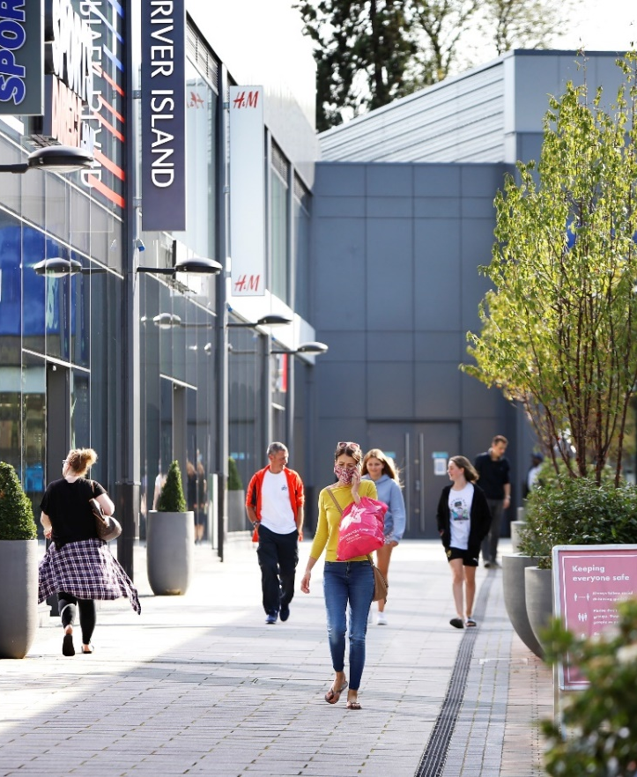
Strategic Lead – Simon Hewings – Head of Finance

Why?

Coronavirus has cost, and lost, the Council money. Many years of austerity before that, as well as a failure to increase Council tax in line with growing costs, makes it hard to balance the books. The future funding picture for Councils from Government remains unclear. In order to deliver a progressive and ambitious agenda, we need to reduce the gap between income and expenditure in our Medium-Term Financial Plan.

So:

We will invest to save and act responsibly and ethically with our financial resources. We will work with other Councils for fair funding and will investigate new viable sources of revenue in order to maintain and improve vital services. We will ensure all financial operations and reporting support effective decision making and strong, ethical governance.

Key Activity in Q1:

To invest, save and act responsibly and ethically with our financial resources, South Oxfordshire are progressing a cost options analysis for the new Council offices. This work is being supported with the assistance of our external advisors to ensure it is robust.

The Strategic Property Review is scheduled to progress through Cabinet and Council in September and October. The supporting documents around investment, disposal and acquisition will also follow this trajectory.

To further our ambitions to investigate new viable sources of revenue to maintain and improve vital services, the Council is exploring potential for open space Stewardship options at sites in Didcot (e.g. Great Western Park).

An updated CIL Spending Strategy came into force in South on 1 April 2021. This will help allocate funding for the delivery of infrastructure to support development.

In order to support effective decision making and strong ethical governance, climate change implications have been added to all formal document templates – including finance reports. Environmental, social and governance criteria are also currently being discussed with the Council’s treasury management advisors. This remains a work in progress but is an important step to ensuring that the Council acts responsibly and ethically.

We have strengthened the capacity to support signposting and access to external funding opportunities. This new approach has supported the submission of Levelling Up Fund and exploring the potential for Public Sector Decarbonisation Fund bids this Quarter. We have also started to explore the possibility of a flexible resource to support external funding bids across the Council, as more opportunities for funding continue to be brought forward from HM Government and other external agencies. We need to consider how to position the Council to take advantage of financial opportunities as they arise.

Performance Measures

Corporate Plan ID | Stated Aim/Project description | Measure | Cabinet Lead | Officer Lead | Performance Update
IRFV1 | Develop and implement an innovative Transformation Strategy to diversify our revenue streams, improve our effectiveness and secure our on-going viability | Narrative measure relating to the development of an overarching Transformation Strategy and any overall narrative linking to potential deliverables  Quantitative data - Income relative to Net expenditure (in context), this could be broken down by service. | Cllr Leigh Rawlins | Adrianna Partridge | The Property Investment Strategy is currently being progressed.  A funds review is being supported by the Council’s external advisors Link to enable us to consider different investments.
IRFV2 | “Invest to save” for the District, including the delivery of sustainable new Council offices – on time and within budget – to realise future operational efficiencies | Narrative on progress of the Corporate Office project, including data on current spend on office accommodation which will no longer be spent once project completed. Further narrative to discuss impact of new building finances. | Cllr Leigh Rawlins | Adrianna Partridge | A cost options analysis for the new Council offices on an invest to save basis is being progressed. This work is being supported with the assistance of our external advisors Link.
IRFV3 | Exercise strong Stewardship of all Council assets including property and financial investments, optimising their performance for the benefit of our residents | Narrative update on the progress of the SPR, in the initial period detailing the scope and scape, then once SPR has been delivered, the outcomes and future measures (quant element) | Cllr Leigh Rawlins | Chris Traill | The Didcot Garden Town and Technical Services Teams are working together to explore the potential for open space stewardship options at Great Western Park and other sites.

Corporate Plan ID | Stated Aim/Project description | Measure | Cabinet Lead | Officer Lead | Performance Update
IRFV4 | Maximise external funding opportunities to support our services and to enrich our leisure, sporting and community activities | Narrative update relating to external funding utilisation, both funding received direct to the Council, and projects which have received part external funding or are in progress if not already delivered.  Specific elements which should be included - Proportion of spend on leisure/community facilities vs amount funded by Council.  CIL/106 spend broken down by type/parish  Externally funded Capital schemes  Total External funding received figure - narrative should be clear that this is not the total figure. | Cllr Maggie-Fillipova Rivers | Chris Traill | The Council was unable to submit a grant application for the Public Sector Decarbonisation Scheme in respects of Thame Leisure Centre due to the very tight eligibility criteria.  Sport England will pay for a consultant to deliver a Strategic Options Planning Guidance report to help scope the Community Wellbeing Strategy. The total value of this is expected to be around £5,000.  The CIL spending strategy was updated in December 2020. It came into force on 1 April 2021.  Quarterly CIL and S106 spend/income reports are provided to Cabinet Members.  The CIL charging schedule is currently being reviewed by the Planning team.
IRFV5 | Invest responsibly and ethically with the Climate Emergency at the heart of what we do | Narrative update detailing changes which have included climate elements into regularised decision making. | Cllr Leigh Rawlins | Simon Hewings | Climate change implications have been added to all document templates – including finance reports. Environmental, social and governance criteria are currently being discussed with the Council’s treasury management advisors. It remains a work in progress.

Covid-19 Response and recovery

Covid-19 has been an unprecedented challenge which required the Council to react quickly to changing circumstances in order to support local businesses, the economy, the voluntary and community sector and local residents. We have worked hard to maintain essential services whilst redeploying staff to new areas of work to help deal with the crisis. The Council developed a Community Hub team during the pandemic to work effectively with voluntary sector partners and volunteers.
This team continue to collaborate with our partners at a County-wide level. More specifically, it facilitates coordination and good communication between the County, City and District Councils, with the NHS and OxLEP, to support vulnerable people and encourage vaccination uptake in the district.

COVID-19 Community Hub Support distributed between 1 April and 30 June
7
FOOD PARCELS
27
TEST & TRACE PAYMENTS

£4.6 m
TO LOCAL BUSINESSES
33
VOUCHER REFERRALS

£131,099
TO VOLUNTARY SECTOR AND HOUSEHOLDS

