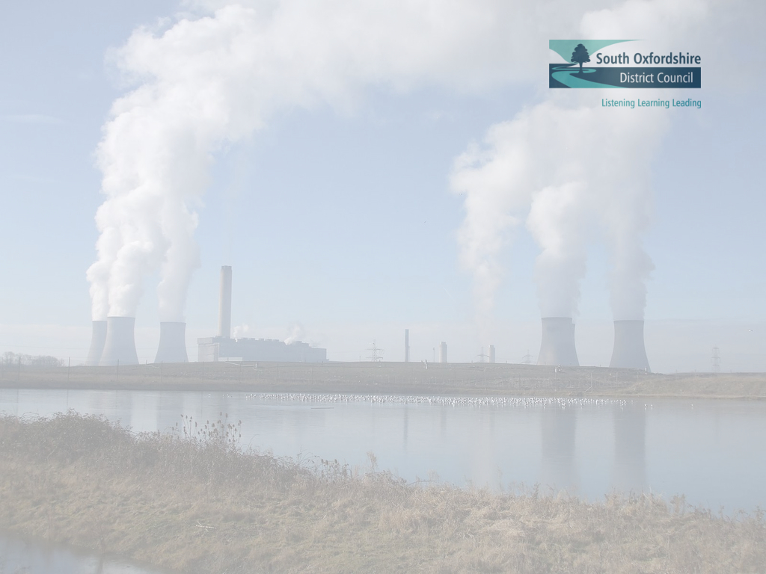

Annual Greenhouse Gas Emissions Report 2019/20
SOUTH OXFORDSHIRE DISTRICT COUNCIL

Greenhouse gas emissions reporting requirements
Since 2011, the Department for Business, Energy & Industrial Strategy has required local authorities to measure and report greenhouse gas emissions from their estate and operations. 2019/20 is the tenth year of reporting and 2009/10 represents the baseline year.

Their guidance draws on the principles of the Greenhouse Gas Protocol, an internationally recognised standard for corporate accounting and reporting of greenhouse gas emissions. Under the protocol all six greenhouse gases are taken into consideration namely, carbon dioxide (CO₂), methane (CH₄), nitrous oxide (N₂O), perfluorocarbons (PFCs), hydrofluorocarbons (HFCs) and sulphur hexafluoride (SF₆) and are reported in terms of tonnes of carbon dioxide equivalent.

Greenhouse gas emissions reporting period April 2009 – March 2020
Table one shows South Oxfordshire District Council greenhouse gas emissions between 2009/10 and 2019/20 measured in tonnes of CO₂ equivalent (tCO₂e). Across all scopes, emissions have fallen by 2,204 tCO₂e – equivalent to a 41 per cent reduction – since 2009/10. Scope one emissions from gas and oil use in buildings and fuel use in fleet vehicles have decreased by 746 tCO₂e, equivalent to a 26 per cent reduction. Scope two emissions from purchased electricity fell by 68 per cent – equivalent to a reduction of 1,086 tCO₂e. Scope three emissions from business mileage, contractor energy and fuel use, well to tank (WTT) processes and transmission and distribution losses fell by 371 tCO₂e, equal to a reduction of 37 per cent.

Table One: South Oxfordshire District Council greenhouse gas emissions 2009/10 – 2019/20

 | tCO₂e
Scope | Baseline 2009/10 | 2010/11 | 2011/12 | 2012/13 | 2013/14 | 2014/15 | 2015/16 | 2016/17 | 2017/18 | 2018/19 | 2019/20 | Change since 2009/10 | % change since 2009/10
Scope one | 2,820 | 2,594 | 2,462 | 2,422 | 2,422 | 2,480 | 2,452 | 2,399 | 2,274 | 2,068 | 2,074 | -746 | -26%
Scope two | 1,610 | 1,447 | 1,221 | 1,162 | 1,092 | 1,217 | 1,001 | 922 | 809 | 809 | 524 | -1086 | -68%
Scope three | 999 | 936 | 852 | 857 | 901 | 929 | 880 | 838 | 814 | 802 | 628 | -371 | -37%
Gross emissions | 5,429 | 4,977 | 4,535 | 4,441 | 4,414 | 4,626 | 4,333 | 4,160 | 3,896 | 3,680 | 3,225 | -2,204 | -41%
Carbon offsets | 0 | 0 | 0 | 0 | 0 | 0 | 0 | 0 | 0 | 0
Green tariff | 0 | 0 | 0 | 0 | 0 | 0 | 0 | 0 | 0 | 0
Scope | 5,429 | 4,977 | 4,535 | 4,441 | 4,414 | 4,626 | 4,333 | 4,160 | 3,896 | 3,680 | 3,225 | -2,204 | -41%

Table two shows in greater detail the sources of greenhouse gas emissions for each scope

Table Two: South Oxfordshire District Council greenhouse gas emissions 2009/10 – 2019/20

 | tCO₂e
Scope |  | Baseline 2009/10 | 2010/11 | 2011/12 | 2012/13 | 2013/14 | 2014/15 | 2015/16 | 2016/17 | 2017/18 | 2018/19 | 2019/20 | Change since 2009/10 | % change since 2009/10
One | Gas consumption | 1,369 | 1,284 | 1,249 | 1,263 | 1,169 | 1,197 | 1,218 | 1,113 | 1,065 | 917 | 1,031 | -338 | -25%
 | Facilities fleet | 5 | 7 | 5 | 5 | 5 | 6 | 7 | 2 | 0 | 1 | 2 | -3 | -60%
 | Waste team |  |  |  |  |  |  |  |  |  |  | 1
 | Waste fleet diesel | 1,447 | 1,303 | 1,209 | 1,154 | 1,248 | 1,277 | 1,228 | 1,285 | 1,209 | 1,150 | 1,039 | -408 | -28%
 | Total scope one | 2,820 | 2,594 | 2,462 | 2,422 | 2,422 | 2,480 | 2,452 | 2,399 | 2,274 | 2,068 | 2,074 | -746 | -26%
Two | Purchased electricity | 1,610 | 1,447 | 1,221 | 1,162 | 1,092 | 1,217 | 1,001 | 922 | 809 | 809 | 524 | -1,086 | -68%
 | Total scope two | 1,610 | 1,447 | 1,221 | 1,162 | 1,092 | 1,217 | 1,001 | 922 | 809 | 809 | 524 | -1,086 | -68%
Three | WTT Gas | 134 | 126 | 122 | 130 | 178 | 161 | 164 | 151 | 161 | 139 | 134 | 0 | 0%
 | WTT facilities fleet | 1 | 1 | 1 | 1 | 1 | 1 | 2 | 0 | 0 | 3 | 0.6 | -0.4 | -40%
 | WTT Waste Team |  |  |  |  |  |  |  |  |  |  | 0.3
 | WTT waste fleet diesel | 301 | 271 | 251 | 261 | 277 | 284 | 276 | 273 | 288 | 274 | 247 | -54 | -18%
 | Finance contractor | 36 | 29 | 18 | 19 | 16 | 15 | 13 | 13 | 7 | 8 | 8 | -28 | -78%
 | Leisure contractor | 2 | 2 | 3 | 3 | 5 | 5 | 5 | 6 | 6 | 5 | 5 | 3 | 50%
 | Waste contractor | 48 | 93 | 48 | 58 | 39 | 51 | 55 | 46 | 21 | 43 | 30 | -18 | -38%
 | Ground maintenance contractor | 19 | 22 | 14 | 13 | 13 | 15 | 22 | 22 | 21 | 21 | 20 | 1 | 5%
 | Cleaning contractor |  |  | 13 | 7 | 8 | 8 | 8 | 7 | 5 | 4 | 5
 | Facilities contractor |  |  |  |  |  |  |  | 2 | 4
 | Car parks contractor |  |  |  |  |  |  |  | 2 | 3 | 14 | 5
 | Council business travel | 97 | 68 | 89 | 86 | 84 | 81 | 91 | 81 | 80 | 74 | 50 | -47 | -49%
 | Scope 2 WTT electricity | 234 | 208 | 187 | 187 | 187 | 201 | 161 | 151 | 141 | 141 | 79 | -155 | -66%
 | Scope 2 T&D losses electricity | 127 | 117 | 104 | 92 | 93 | 106 | 83 | 83 | 76 | 76 | 44 | -83 | -65%
 | Total scope three | 999 | 936 | 852 | 857 | 901 | 929 | 880 | 838 | 814 | 802 | 628 | -371 | -37%
 | Total emissions | 5,429 | 4,977 | 4,535 | 4,441 | 4,414 | 4,626 | 4,333 | 4,160 | 3,896 | 3,680 | 3,225 | -2,204 | -41%

Figure one shows greenhouse gas emissions from council operations between 2009/10 and 2019/20 across each scope

Figure One: South Oxfordshire District Council greenhouse gas emissions 2009/10 – 2019/20

Table three shows the breakdown of greenhouse gas emissions by gas type

Table Three: 2019/20 CO_{2,} CH₄ and N₂O emissions

Scope | 2019/20
 | CO₂ | CH₄ | N₂O
Scope one | 2,057.8 | 1.5 | 14.3
Scope two | 519.6 | 1.3 | 2.8
Scope three | 143.5 | 0.3 | 1.0
Total | 2,720.9 | 3.1 | 18.1

Contextual analysis
Along with other Oxfordshire councils, South Oxfordshire District Council is committed to the Oxfordshire 2030 priority to reduce greenhouse gas emissions. The objective is to reduce carbon emissions from the local authority estate by an average of 3 per cent annually against a 2010/2011 baseline.

At a meeting of the Full Council on 11 April 2019, South Oxfordshire declared a Climate Emergency. This committed the council to working towards reducing its impact upon the environment. To facilitate this, a Climate Emergency Advisory Committee was established to advise on how South Oxfordshire can contribute to carbon reduction targets and minimise damage to the environment through its policies and practices. At its inaugural meeting on 19 September 2019, the Committee recommended that South Oxfordshire should become a carbon neutral council by 2025 and a carbon neutral district by 2030 – these targets were endorsed by the Cabinet and Full Council on 8 October 2019 and 10 October 2019 respectively. An ongoing programme of work has been developed to assist and guide South Oxfordshire in achieving its climate change ambitions.

South Oxfordshire District Council has achieved fuel efficiencies through fleet changes. Overall fuel use has reduced by around 10 per cent since the fleet was replaced. This is partially down to the new vehicles having more efficient engines, but also due to changes in the collection methodology (providing separate vehicles for wheeled bins and food waste) which have significantly improved operational efficiency. The projected reduction in fuel use is over a litre per household per annum.

On 13 March 2020, council staff were advised to work from home if possible due to the coronavirus. Ten days later, the United Kingdom entered a full nationwide lockdown. This led to the closure of council owned and operated buildings throughout the district and the prohibiting of all but essential travel. These measures will, therefore, have reduced South Oxfordshire’s total greenhouse gas emissions at the very end of Q4 2019/20.

In order to give a more accurate indication of the greenhouse gas emissions generated, and to better reflect the shared nature of the workforce, staff mileage is now divided equally between South Oxfordshire and Vale of White Horse.

The carbon factor for electricity has reduced by ten per cent in the last year, which has impacted favourably on the scope two emissions reported by the council – since 2009, the carbon factor for electricity has reduced by just under 50 per cent.

Data Set
The approach set out in the Greenhouse Gas Protocol is to identify and categorise emissions-releasing activities into three groups, known as scopes. The guidance recommends reporting scope one and scope two emissions, but states that reporting scope three emission is discretionary. The three scopes are:

Scope one, direct emissions:
Activities owned or controlled by the council that release emissions straight into the atmosphere. Scope one emissions include emissions from combustion in owned or controlled boilers, furnaces and vehicles.

Scope two, indirect energy:
Emissions being released into the atmosphere associated with the council’s consumption of purchased electricity. These are indirect emissions that are a consequence of the council’s activities, but which occur at sources the council does not own or control.

Scope three, other indirect:
Emissions that are a consequence of the council’s actions that occur at sources which the council does not own or control and which are not classed as scope two emissions. Examples of scope three emissions are business travel by means not owned or controlled by the council, well to tank processes and electricity transmission and distribution losses.

The Department for Business, Energy & Industrial Strategy has not imposed exact instructions on what local authorities should include in their annual greenhouse gas emissions report. The council has identified activities which are responsible for greenhouse gas emissions being released into the atmosphere. These include energy use in all buildings occupied by either the council or its contractors, fuel use in plant and equipment operated by the council or its contractors and fuel use by vehicles owned or used by the council and its contractors.

Emissions from residential waste collection are included under scope one however, emissions from the treatment and disposal of residential waste are not included. Emissions from the collection and disposal of waste from council offices, water use and staff commuting have also been excluded due to insufficient data and difficulties obtaining data. The council will work towards including these emissions in future reports. Emissions of PFCs, HFCs and SF6 have not been included in this report as council activities are not significant sources of these gases.

Emissions associated with the extraction, refining and transportation of raw fuels before their combustion are referred to as well to tank (WTT) processes and form part of scope three emissions. Emissions associated with electricity transmission and distribution losses are also included in scope three.

Table Four: Council greenhouse gas emissions sources under each scope

Scope One | Scope Two | Scope Three | Scope Four
Gas and oil use in council offices, civic buildings, leisure centres and temporary accommodation hostels | Electricity use in council offices, civic buildings, leisure centres, temporary accommodation hostels, car parks, CCTV, public conveniences, pumping stations and sewage treatment works | Contractor electricity, gas, oil and fuel use and mileage | Perfluorocarbons, hydrofluorocarbons and sulphur hexafluoride
 |  |  | Staff commuting
Fuel used in council vehicle fleet |  | Business mileage by car | Council office waste collection, treatment and disposal
 |  | Business mileage by public transport | Water
Fuel used in waste collection vehicle fleet |  |  | Residential waste treatment and disposal
 |  | WTT processes and transmission and distribution losses
 |  |  | Fugitive emissions

Data collection and methodology
The Department for Business, Energy & Industrial Strategy and Defra publish joint guidance for local authorities on how to report and measure their greenhouse gas emissions including annually updated greenhouse gas conversion factors. Greenhouse gas emissions for 2019/20 have been reported in line with the joint DECC/Defra guidance published in June 2013 and calculated using the 2019 conversion factors. In line with the guidance, emissions from electricity are no longer calculated using the five-year grid rolling average and are instead calculated using the average conversion factor applicable to the reporting year.

Energy and fuel use in council and contractor buildings, plant, equipment and vehicles and the resulting carbon dioxide emissions have been reported annually since 2007 when the council established its carbon management plan. Data is manually collected on a monthly basis or in some cases quarterly. Each service area is responsible for collecting and collating data on energy consumed in delivering their services. Contractors are responsible for collecting and passing data to client managers on a monthly or quarterly basis.

It should be noted that electricity consumption for the council’s office during 2015/16 was modelled. Following a fire at its office in January 2015, South Oxfordshire District Council moved into leased temporary office accommodation between late June and late July 2015. The electricity supply at the new office has one fiscal utility meter that feeds both the council’s electrical load as well as a data centre, which is the responsibility of the landlord. On 8 April 2016 the council installed a sub-meter to measure their consumption however, in the absence of sub-meter data during the period 1 April 2015 to 31 March 2016 the council required a reliable estimate of their own electricity consumption to inform their greenhouse gas emissions reporting. The council therefore appointed an environmental consultancy, EEVS Insight Ltd (Energy Efficiency Verification Specialists), to carry out an analysis of the electricity consumption data from the fiscal utility meter and the council’s sub-meter to model the electricity consumption in the building which can be attributed to South Oxfordshire District Council.

Carbon offsetting

Green tariff
Currently the council does not purchase any electricity from a green tariff.

Carbon offsets - renewable technologies
Solar photovoltaic panels are installed on some public conveniences owned by the council. The amount of energy generated by these systems has not been included in this report due to insufficient data.

As a result of rounding, the totals presented may be slightly different to the sum of the individual values.
As a result of rounding, the totals presented may be slightly different to the sum of the individual values.
https://www.gov.uk/guidance/measuring-and-reporting-environmental-impacts-guidance-for-businesses

